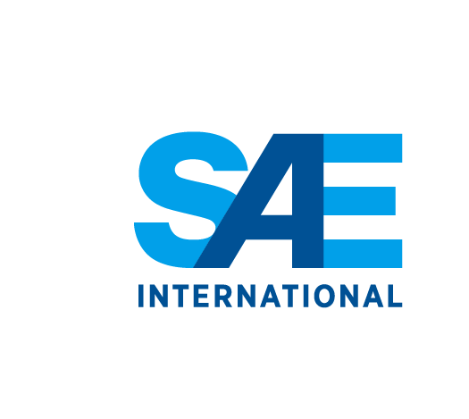

400 Commonwealth Drive, Warrendale, PA 15096-0001 U.S.A.
Phone: 724-776-4841; Fax: 724-776-0243

The next meeting of the SAE AGE-2A Cargo Handling Committee will be held on April 12-13, 2016 in Geneva, Hosted by IATA

MEETING LOCATION

International Air Transport Association
IATA Centre
33 Route de l'Aéroport
PO Box 416
Geneva 15 Airport
1215

HOTEL OPTIONS

Meeting Information

Hotel information will be posted when available

Meeting Schedule/Agendas:
A meeting schedule/agenda will be posted on the committee website when available.

SAE Intellectual Property Policy:
SAE's intellectual property is its most valuable asset. As such, the Society expends considerable resources maintaining and protecting its rights to its intellectual property. SAE reserves the right to copyright any of its print products, electronic products, databases, audio/visual products and any other subject matter. This is intended to protect SAE and its members from unauthorized copying and distribution of SAE intellectual property. SAE's intellectual property may only be used in a manner that furthers the organization's purposes.

It is also SAE policy that the copyrights and other intellectual property rights of third parties be respected and not infringed upon by SAE or any of its committees, or any employee, member or other person acting on behalf of SAE.
As a participant in SAE Technical Committees, individuals agree that the collective work of the committee(s) is the property of SAE, and SAE is charged with its publication, dissemination, and protection

If you have additional questions, please contact Sonal Khunti at skhunti@sae.org.

