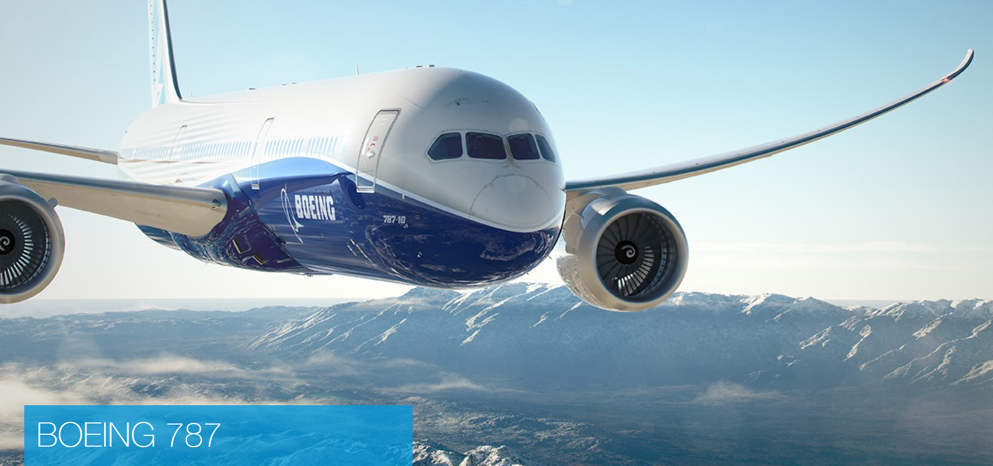

SAE G3 Boeing 787 BSC Factory Tour – Charleston, South Carolina
When: Wednesday March 7th
Transportation: We are required to arrive by Bus or Shuttle Bus. The Boeing Charleston site will not allow us to drive our own vehicles (yes that means rental vehicles and taxi’s as well) to the facility for the tour.
Ron Clements is arranging bus transportation.
The bus will provide round trip service to and from the Holiday Inn Charleston Historic Downtown 425 Meeting Street Charleston, SC 29403
Bus will leave promptly from the hotel at 12:45pm
Estimated drop off back at the hotel is ~ 4:15pm
If you would like to attend the tour, I will need the following information by Monday February 26th:
- First, MI, Last Name:
- Country of Citizenship:
- Company/Organization
- Title
Send info to: ronald.l.clements@boeing.com NOTE: DO NOT SEND BY REPLY TO THE SAE E-MAIL
Attendance is limited to 70 persons so please reserve your place as soon as possible.
COSTS: The tour is free, however, please plan on a ~$22pp charge for transportation (I’m working on a zero cost alternative plan but I do not have approval yet…)

